**Robotics I – Project 7 Fall 2020 – Due Friday Nov 13th**

**Draw a circle and shape with a 2-link manipulator**

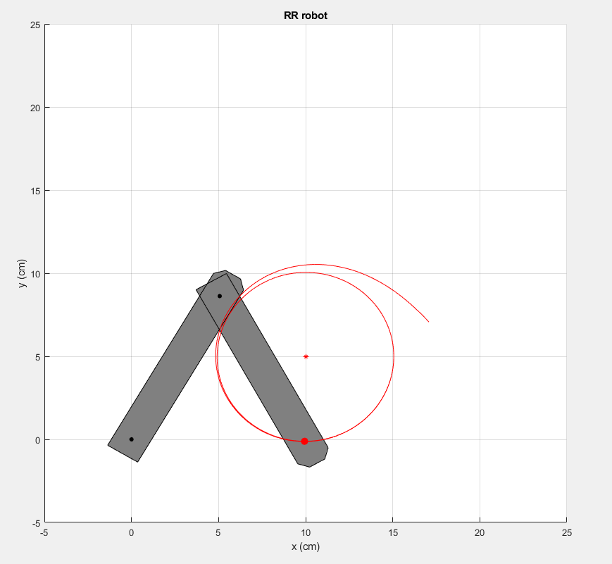

**Project Assignment: Develop and implement code to control the given manipulator end effector position in order to draw both a circle and a provided shape. Each drawing will be independent and selectable by a variable switch in the provided code.**

**The algorithm should be iterative and use the techniques we developed in class, such as circle and line following and mapping the desired workspace end effector velocities to angular velocities of our motors (using the inverse Jacobian). There won’t be any maximum motor speed for this project, however, the desired linear velocity will be set in the code (i.e. v = #)**

**There is a single TODO section for this assignment**

1. **Modify the code in the TopLevelScript_proj9.m script in order to control the manipulator to draw a circle.**
2. **Modify the code in the TopLevelScript_proj9.m script in order to control the manipulator to draw a shape.**